The Effects of Prefetching to Computer
Computer Architecture
Shalin Patel, 0194037
Monroe College | King Graduate School

Introduction
With the fame of multimedia advancement specifications such as MMX, MPEG decompression is progressively executed on universally useful processors rather than devoted MPEG equipment. The hole between processor speed and memory access implies that a lot of time is spent in the memory system. As processor get quicker - both as far as higher clock speed and expanded direction level parallelism - the time spent in the memory framework turns out to be much more critical. Information prefetching is a notable method for moving forward cache execution. While a few investigations have analyzed prefetch procedures for logical and business applications.
Programming prefetching and locality advancements are procedures for conquering the speed hole between processor and memory. Two promising methodologies for enhancing memory execution are programming prefetching and locality optimization. The first executes express prefetch guidelines to start stacking information from memory to reserve. For whatever length of time that prefetching starts sufficiently early and the information isn’t ousted before its utilize, memory get to dormancy can be totally covered up. Yet, as processor throughput moves forward because of memory inertness resilience, memory data transfer capacity utilize is expanded since prefetching increments. In comparison, locality improvements compiler or run time changes to change the calculation arrange and additionally information design of a program to expand the likelihood it gets to information as of now in store. On the off chance that effective, both normal memory latency and data transfer capacity use are decreased, since there will be less primary memory gets to.

Since programs are for the most part executed successively, execution is probably going to be best when guidelines are prefetched in program arrange. On the other hand, the prefetch might be a piece of an intricate branch expectation calculation, where the processor attempts to foresee the consequence of an estimation and get the correct directions ahead of time.
Types of Prefetching:
Prefetching can be classified in many ways.
- Data or Instruction Prefetching
- Hardware or Software Prefetching
Data or Instruction Prefetching:
As the name suggests, the prefetching can be performed for either information blocks or direction blocks. Since information get to designs demonstrate less normality than direction designs, precise information prefetching is for the most part more difficult than guideline prefetching.
Hardware or Software Prefetching:
Prefetching can be performed in either equipment or programming. Equipment prefetchers may utilize some stockpiling to distinguish get to designs and in view of it, prefetch guidelines are issued. Programming prefetchers embed prefetch directions in program source-code in view of learning of program control stream.

Code Optimization:
The degree of the streamlining that should be possible likewise relies upon the processor used to execute the code. A PC chip with a math coprocessor will execute figuring quicker than a PC without the processor. An ongoing change is the scene of Intel's MMX™ Technology. It is intended to quicken mixed media and correspondences applications. The innovation incorporates new directions and information composes that enable applications to accomplish another level of execution. It abuses the parallelism innate in numerous sight and sound and interchanges calculations yet keeps up full similarity with existing working frameworks and applications.
To exploit MMX innovation, the code must be recompiled with a compiler that is MMX perfect. Exceptional device libraries will make this procedure straightforward to the engineer, except if the program is composed in low level computing construct. All things considered, the developer will have more particular directions to stress over. The accompanying table obviously exhibits the run-time points of interest MMX has for picture preparing.
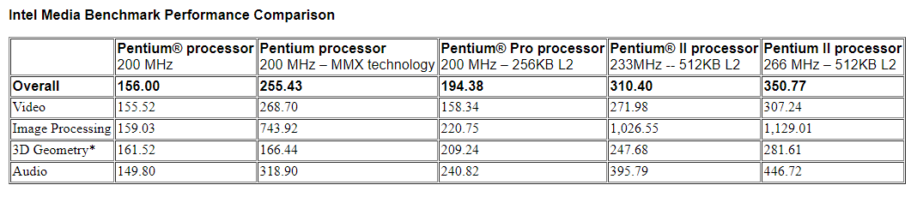

Conclusion
Despite the fact that you can accomplish your outcomes utilizing redo processors, usually more moderate to do it utilizing "off the rack" PCs and modified programming. Code advancement and information prefetching are two methods that will empower those stages to do picture handling at speeds that are worthy.
These systems can't take care of the considerable number of issues. A few applications will in any case require custom-constructed flag preparing equipment that can procedure more data transmission speedier. In any case, as time goes, increasingly of the segments that were utilized to construct particular hardware will appreciate greater fame and turn out to be minimal effort, "off the rack" segments, or could be supplanted by ever quicker multi-reason gear, upgraded for the job needing to be done. One will at that point have the capacity to get similar outcomes at a small amount of the cost.

References:
Instruction prefetch. (n.d.). Retrieved from: https://ipfs.io/ipfs/QmXoypizjW3WknFiJnKLwHCnL72vedxjQkDDP1mXWo6uco/wiki/Instruction_prefetch.html
Daniel Z., Ruby L., Michael F. (August 2000). Hardware and Software Cache Prefetching Techniques for MPEG Benchmarks. Retrieved from: http://www.princeton.edu/~rblee/ELE572Papers/HW%26SWcachePrefetchMPEG_ZuckerLee.pdf
Jun Y. (2003). Prefetching. Retrieved from: https://pdfs.semanticscholar.org/ded4/a0260c7c8fd239bcc54be6e517f1870679b4.pdf
Abdel B., Aneesh A., Donald Y., Chau T. (2004). The Efficacy of Software Prefetching and Locality Optimizations on Future Memory Systems. Retrieved from: https://www.jilp.org/vol6/v6paper7.pdf
Wikipedia. Cache Prefetching. Retrieved from: https://en.wikipedia.org/wiki/Cache_prefetching
Optimizing Computer Runtime Using Data Prefetching and Code Optimization. (n.d.). Retrieved from: https://www.cis.rit.edu/class/simg707/Web_Pages/alain.htm

